* Go to Terminal
  + Create “New Tab”
  + Pull “hello_world” folder into command line
  + Input “git init”
  + Input “git status”
  + Input “git add.”
  + Input “git commit-m ‘first commit’”
  + 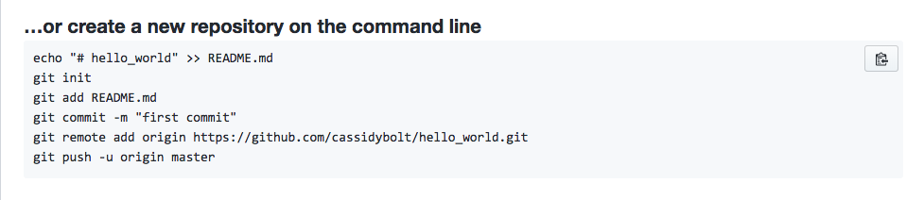
* Push to github🡪come to github pages